1-search PSCP
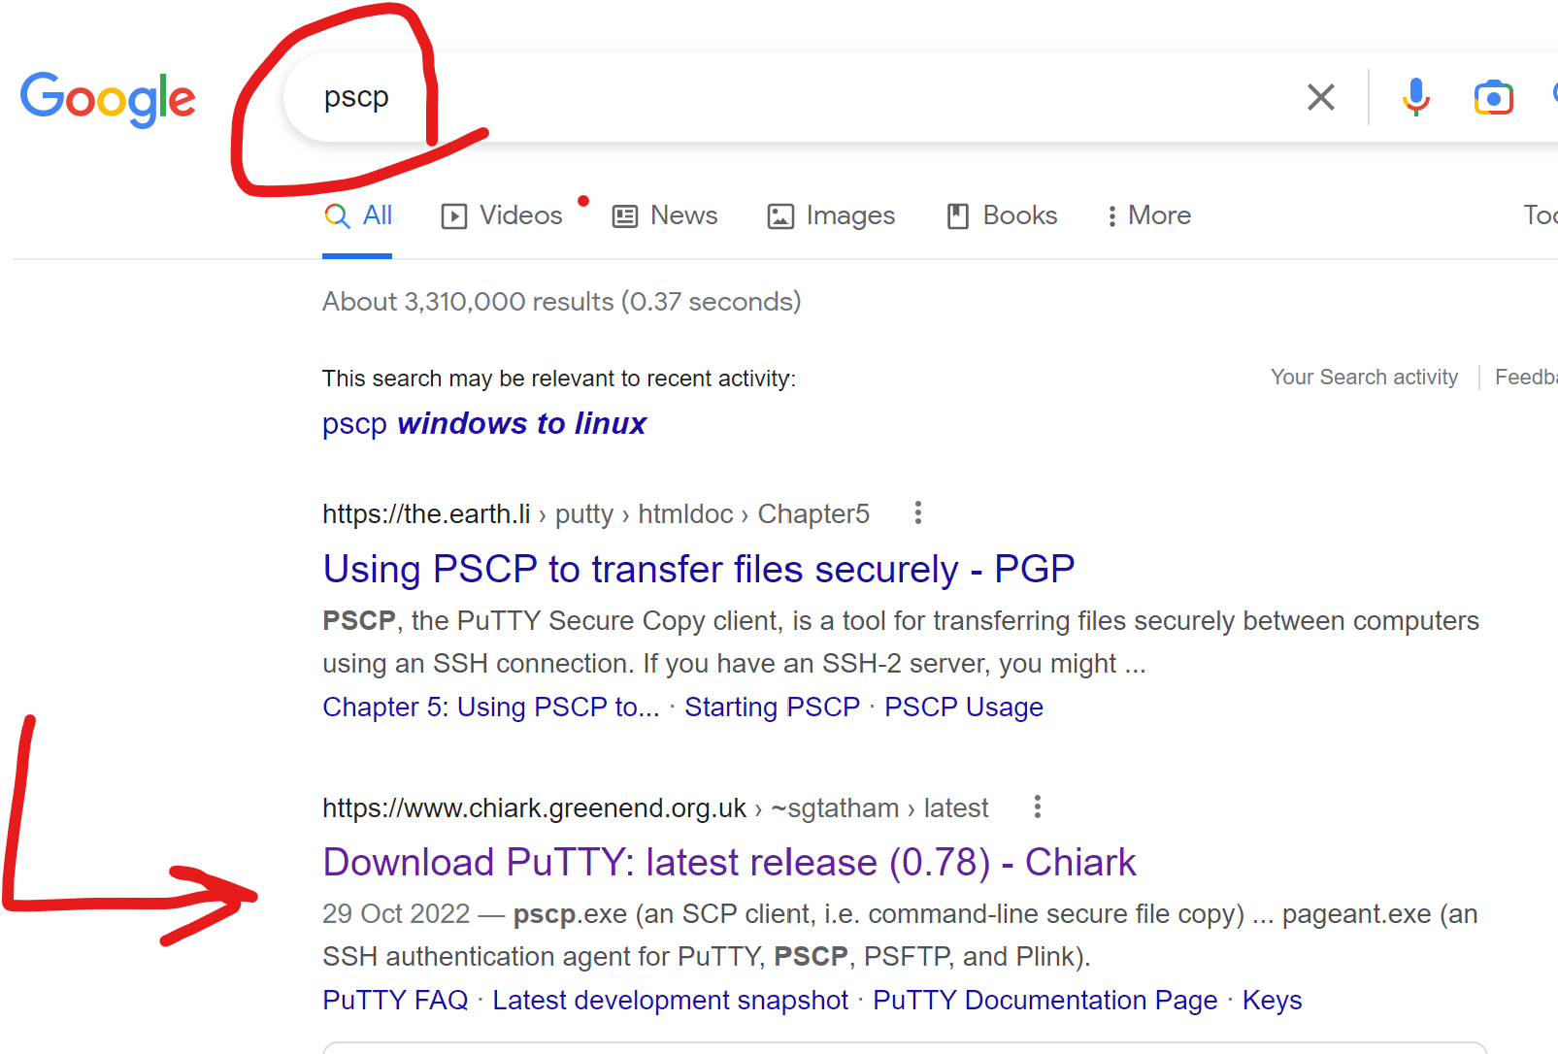
2-download pscp.exe
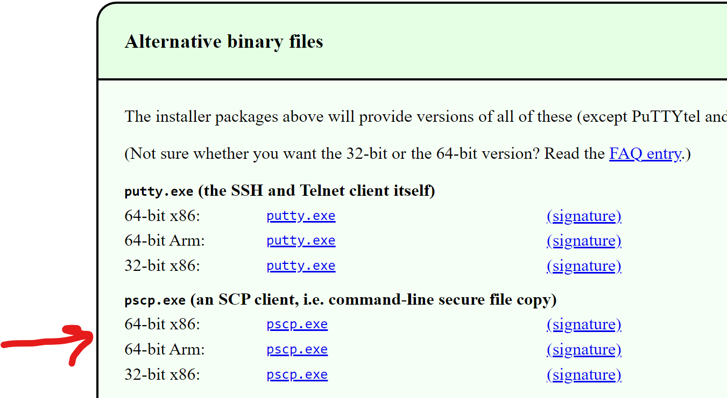
3-put your putty.exe and pscp.exe in the same folder. The copy the file you find to transfer in that folder
+copy your file in this folder
4-Open cmd: and go to the folder by cd command
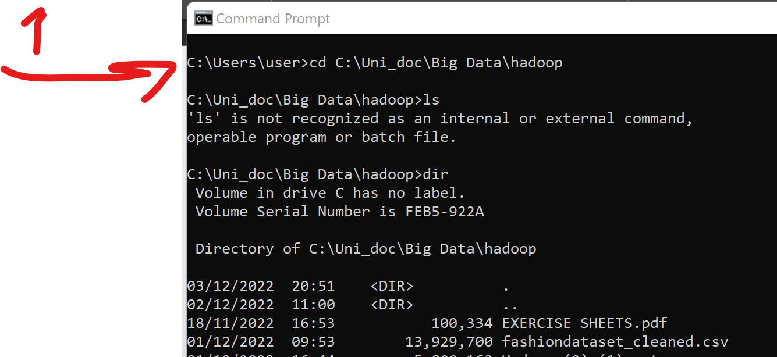
5-Then in the cmd write this command and enter. You will need to enter the password, and now enjoy 😊 .for this step, you need to know some information which are set on your putty. Check the next pictures.
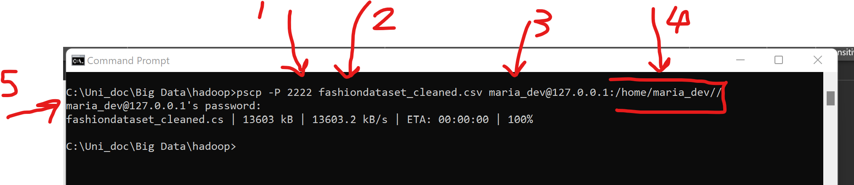
1:port- we set it in putty
2:file name
3: ip address of your vm
4:directory in vm--→ to find this data, open putty and write pwd, the result should be copy hear.
